# 

# 

# 

# 

# 

# 

# Report 3 SENG 2021

Group: ScotchOlive

Team Member:

Matthew Perry z5075269

Ratanak Phalla Kim z3456351

Nicholas Costa z5014851

Xinjian Guo z3446266

Xiaocong Chen z5027195

1.The updated use cases/stories

Use Cases:

**Feature:** Viewing locations on google maps

* **As a:** partygoer
* **So that:** I can explore locations of interest, and discover more destinations close to destinations I have searched for (perhaps to plan additional activities nearby a chosen activity)
* **I want to:** move viewport for the google map and view available locations
* **Scenario:** Curious partygoers want to move around and view any locations on map using Google Maps
  + **Given** I am on the Main Screen
  + **When** I click on the map, hold and drag
  + **Then** the map centre should move in the direction dragged, and display the new geographical area with locations marked by markers

**Feature:** Searching for locations by names

* **As a:** partygoer
* **So that:** I can easily find locations
* **I want to:** search locations by their name on the map screen
* **Scenario:** A partygoer wants to find a specific locations on the map
  + **Given** I am on the Main Screen
  + **When** I enter a location name into the search bar at the top of the screen (such as “The Star”) and press enter
  + **Then** the map should centre this locations on the map, taking up 70% of the screen within 2 seconds and placing a marker with an info-box for it (in this case the “The star”)

**Feature**: partygoers can view a list of videos discussing a selected location, in order of relevance to the location name

* **As a:** partygoer
* **So that:** I can find videos related to the searched location to give me insight into services offered, establishment vibe, and other important information
* **I want to:** view a list of 3 videos sorted according to relevance to the locations name
* **Scenario:** A partygoer wants to view videos related to the location
  + **Given** I am on the Main Screen
  + **When** I search a location on the map page (for example, Silvereye restaurant)
  + **Then** a marker should show on the selected location and a list of text links (the text being the title of the video) to 3 videos should show on the left of the map, with the most preferred on the top, going to the bottom, with preference being determined through relevance to location name

**Feature**: partygoers can watch a video from the (above) list of videos

* **As a:** partygoer
* **So that:** I can watch my choice of video related to the location I am interested in
* **I want to:** view a video displayed in the list
* **Scenario:** view a video
  + **Given** I am on map page and have searched a valid location
  + **When** I click on a video title link
  + **Then** the selected, fully functional YouTube video should display on the center of the screen within 5 seconds

**Feature:** Add location to the trip

* **As a:** partygoer
* **So that:** I can add new location to my trip
* **I want to:** add new location to my trips which the final generated trip will include
* **Scenario:** A partygoer wants to add a bar to the trip list to increase number of destinations
  + **Given** I am on the Main Screen and have selected a bar(which is when a marker appears over a location on the map)
  + **When** I right-click the the map on the location of the bar
  + **Then** a marker is added to the clicked location
  + **When** I click the marker
  + **Then** an info-window will pop up with an “add to list”button
  + **When** I click the “add to list” button
  + **Then** the locations’ coordinates will be added to the trip list

**Feature:** partygoers can remove location from the trip list

* **As a:** partygoer
* **So that:** I continue updating my trip using the application
* **I want to:** remove location from my trip that are no longer of interest to me
* **Scenario:**  A partygoer removes location from trip to reflect his future destinations
  + **Given:** I am on the Main Screen and there are locations in the location list
  + **When** I click on the marker
  + **Then** an info-window will pop-up
  + **When** I click remove from the list
  + **Then** the location listed will be removed from the trip list, with the locations below being shifted upwards within 0.5 seconds

**Feature:** partygoers can get recommendations for places to go

* **As a:** partygoer
* **So that:** I can decide on a destination according to a category of interests I have
* **I want to:** get some recommendations based on my current interests
* **Scenario:** A partygoers wants to decide on a dining location
  + **Given** I am on the Main Screen
  + **When** I click on the “Suggest something to me” button
  + **Then** I am taken to the recommendation page
  + **When** I click on the food and drink picture
  + **Then** I am taken to the dining recommendation page
  + **When** I click on the restaurant picture
  + **Then** I am taken to the Main Screen, and a popup appears, suggesting to enter the search term “restaurant”

**Feature:** partygoers can get optimised route map and information for their destinations

* **As a:** partygoer
* **So that:** I can determine the most efficient route to take between my destinations
* **I want to:** view a map and information informing me of the most efficient route
* **Scenario:** A partygoer will be visiting multiple destinations during the night, such as restaurants and a cinema
  + **Given** I am on the Main Screen and have items in my trip list
  + **When** I click on the “give me directions” button
  + **Then** I am taken to the directions page which shows a map with the roads in the most time-effective route to cover all of the destinations starting and ending in my current GPS location coloured in pink, and on the right of the map a list of information about each segment of the trip in order of when they occur from top to bottom (with each segment of information showing the starting and ending addresses and the distance to be travelled)
* **Focus on what has been achieved. Show final interface screenshots**

Screen shots:

Home page:

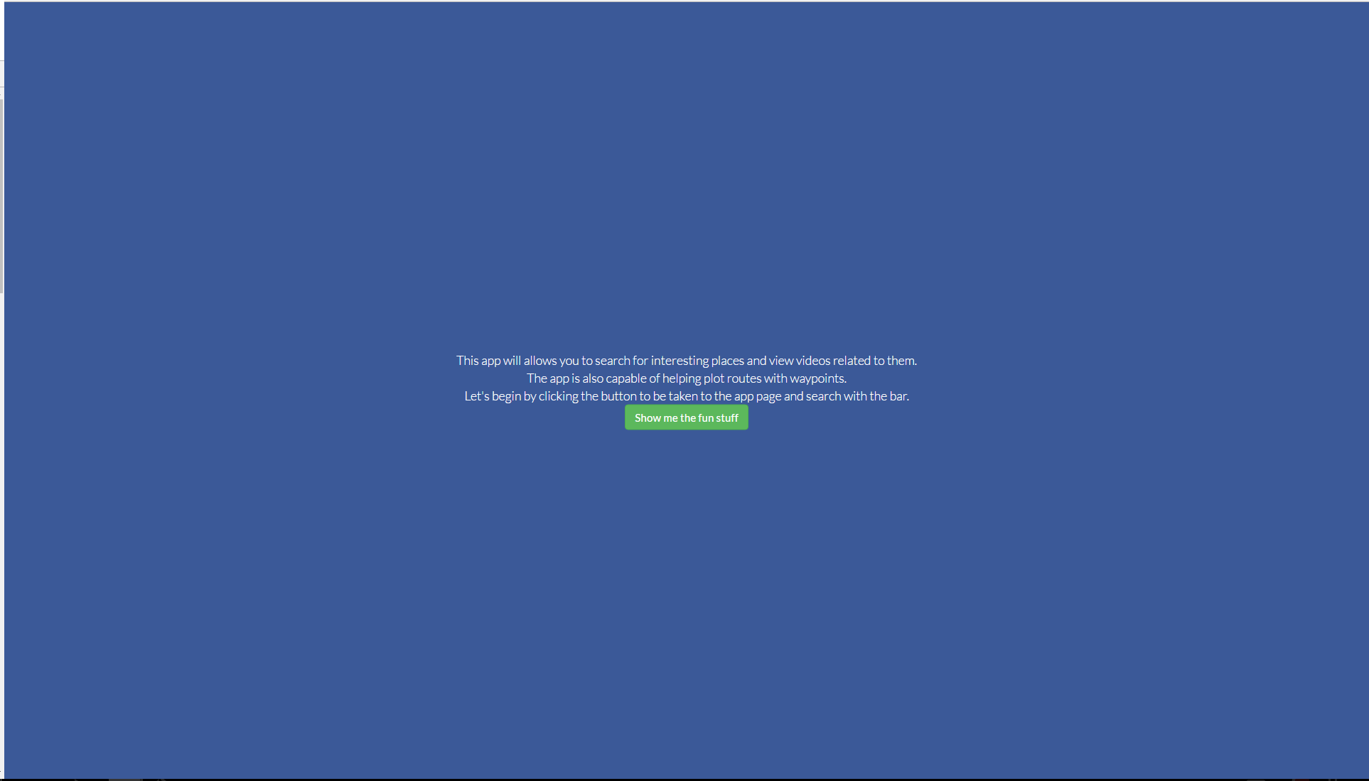

Map page:

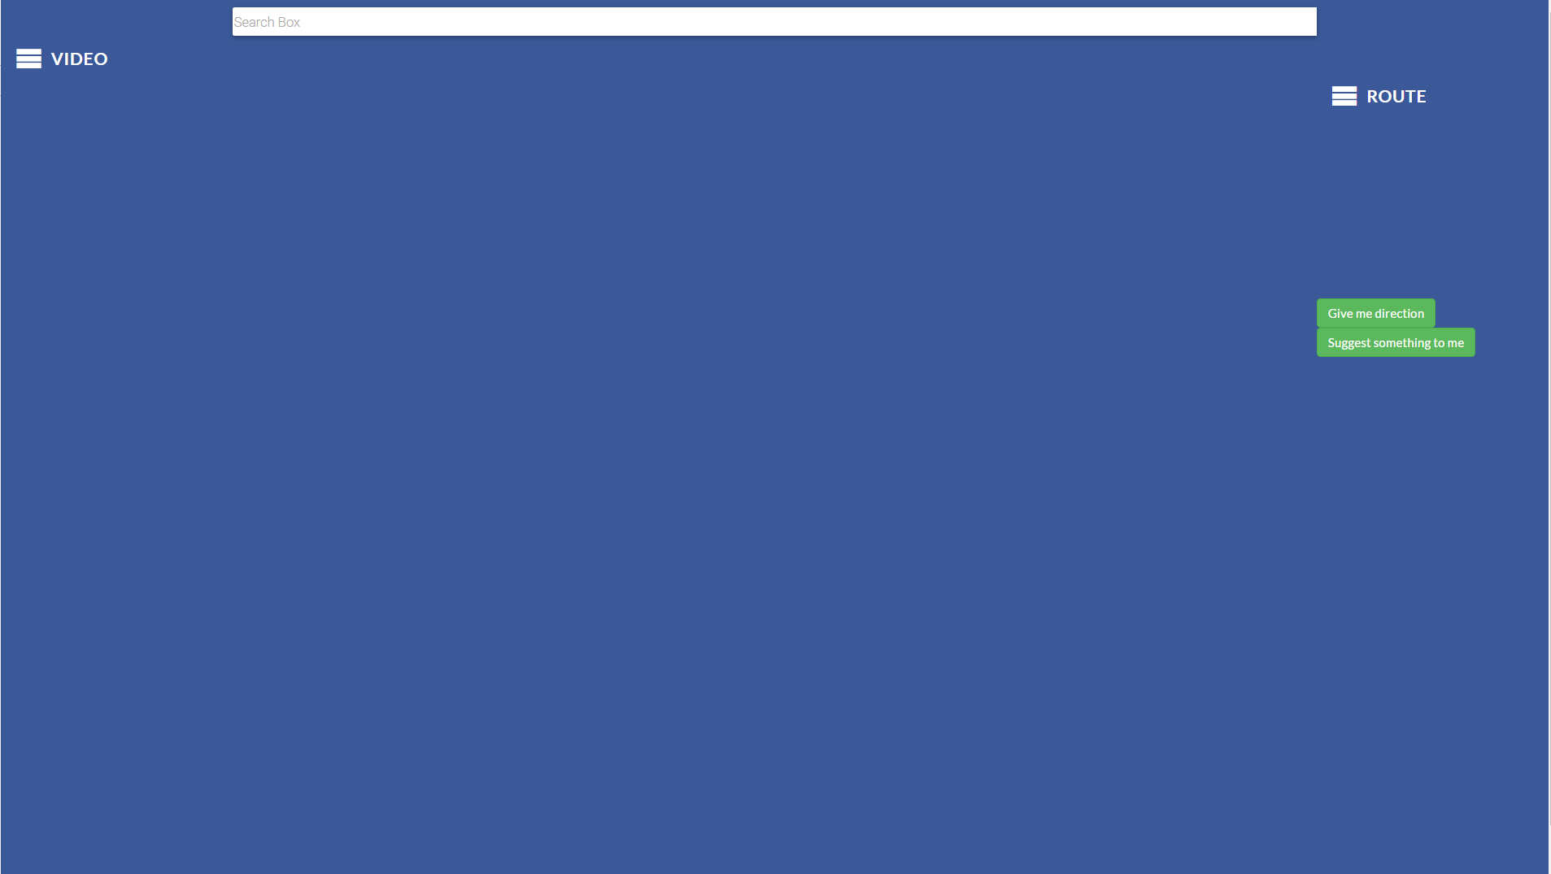

Map page with map shown:

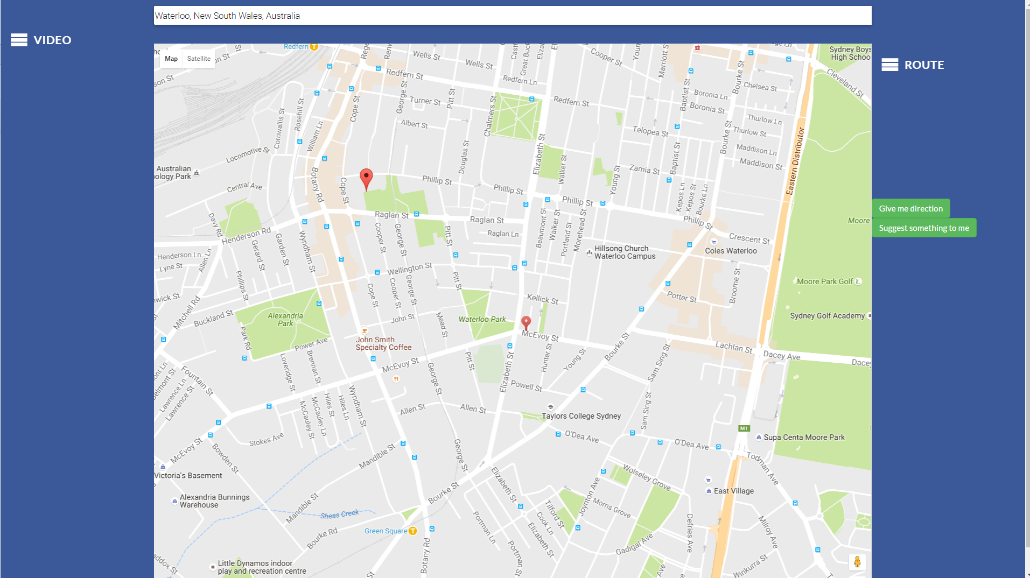

Map page with video:

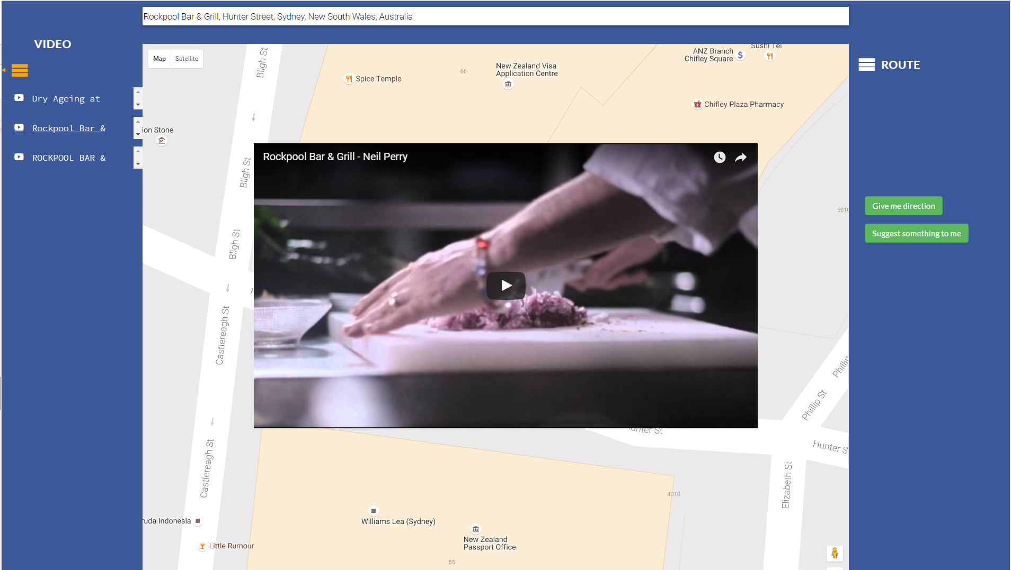

Direction page:

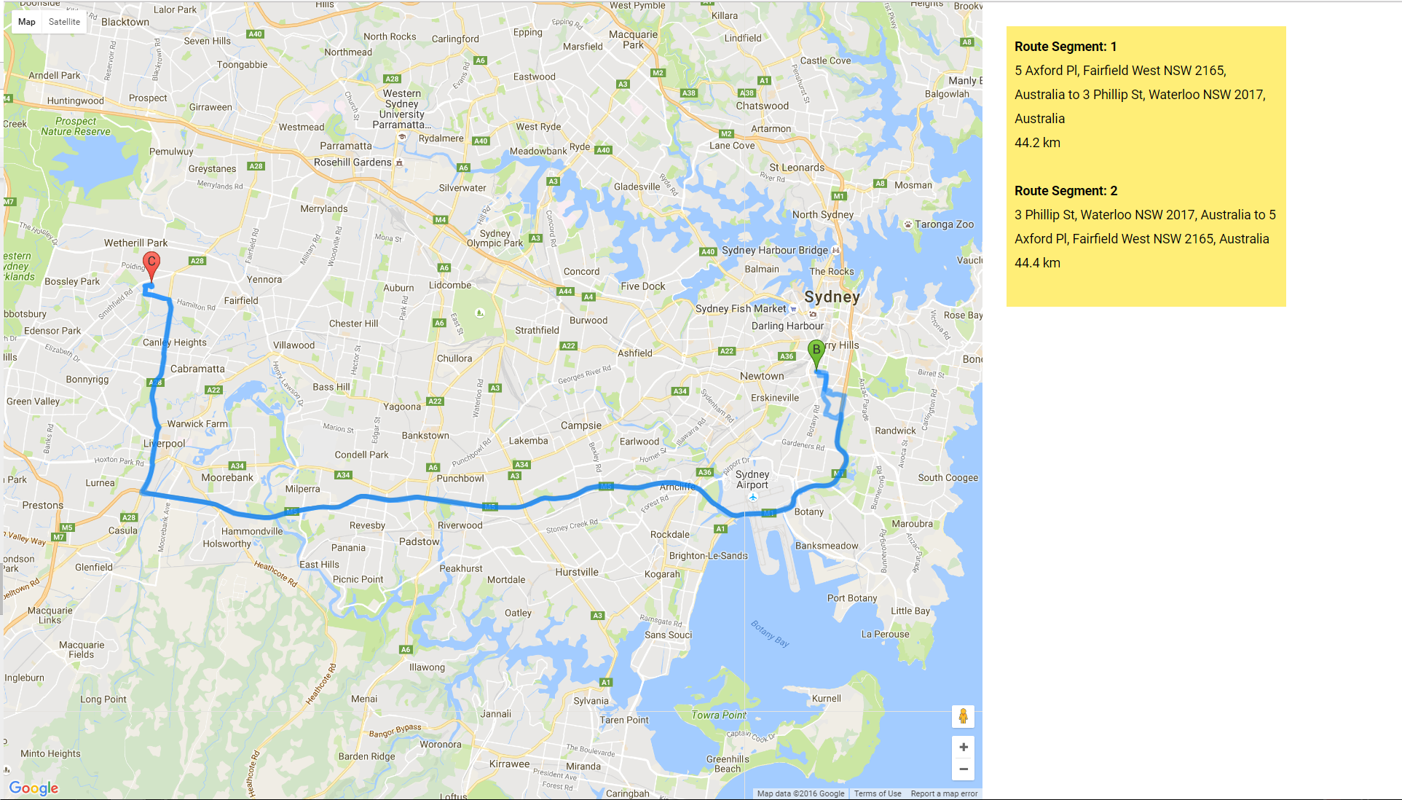

Suggestion page:

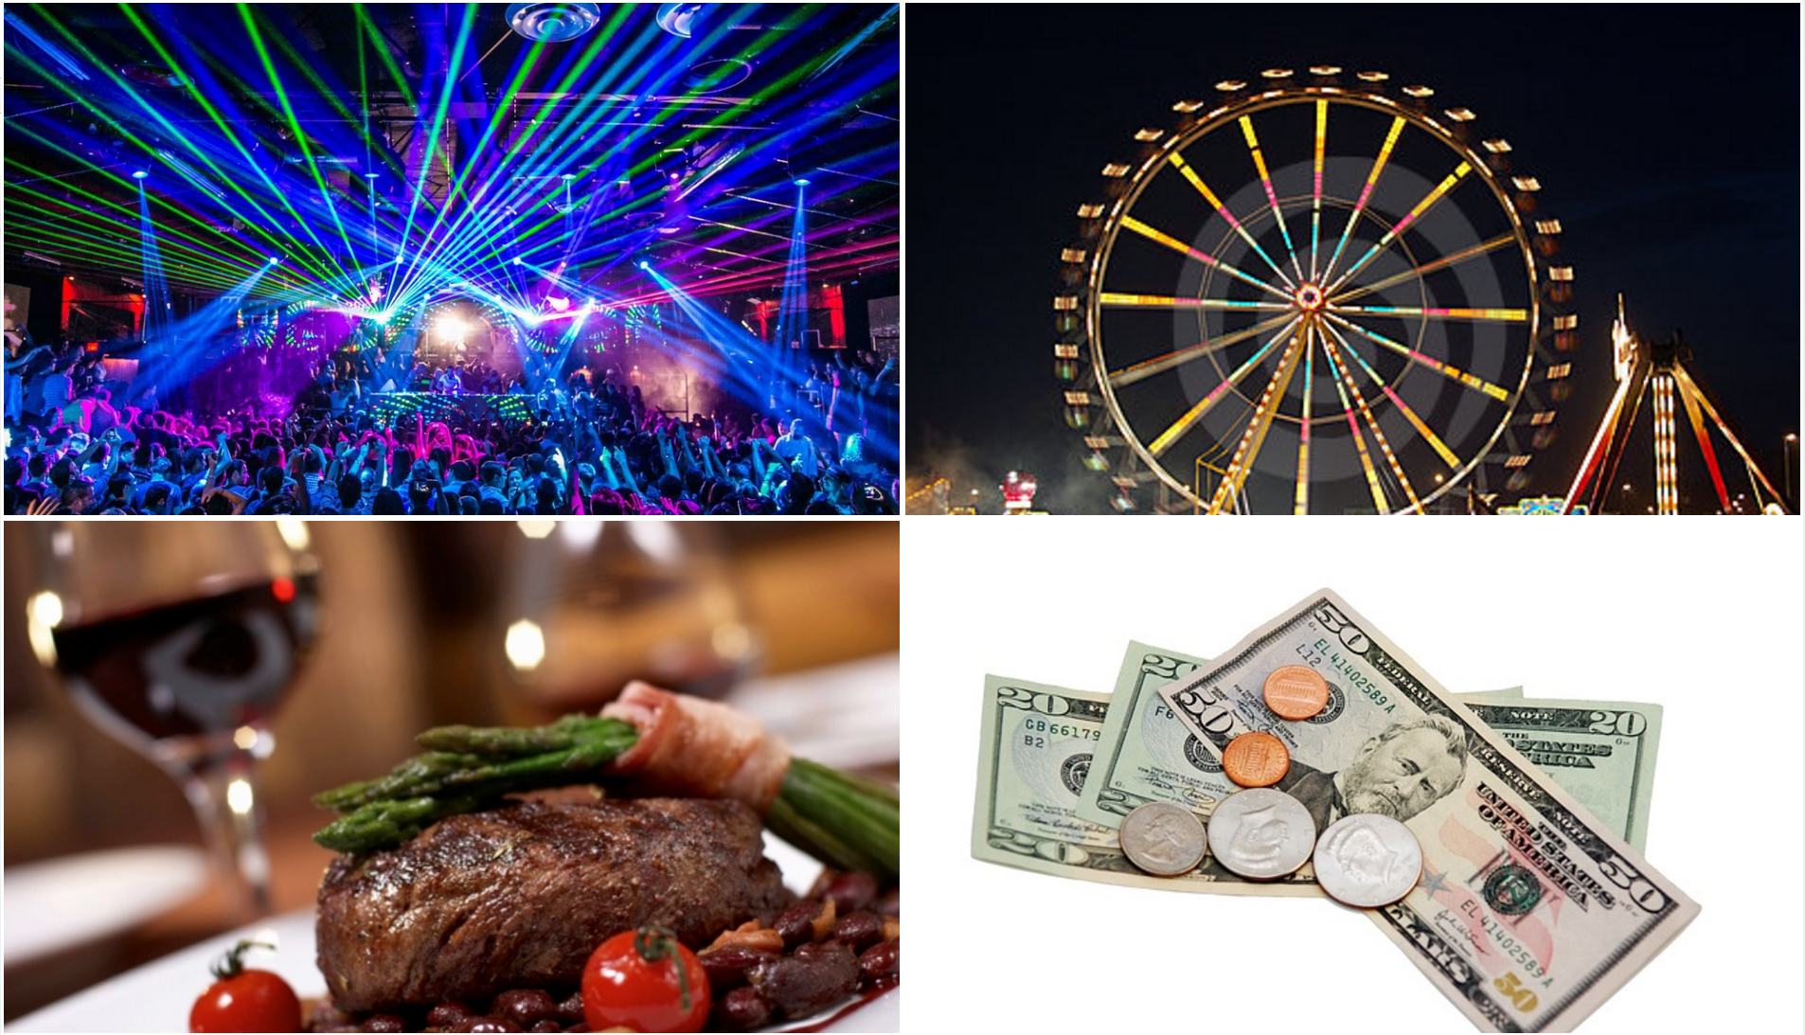

2.The updated design and information on prototype implementation

* **Final software architecture** 
  + Front-end: html5+javascript+css
  + Middle-end:Javascript
  + Back-end: none
  + Framework: Django,(React as first report mentioned? Not in it)

The system is built on the Django framework to provide MVC functionality, with the front-end developed using existing CSS components(i.e. Bootstrap components), HTML5 and JavaScript. There is no back-end as the system relies on querying multiple Google APIs and YouTube data APIs thru HTTP requests before formatting and serving the response to the front-end.

The front-end’s main role is to provide a webpage for the client to view the map and videos returned by the APIs and to receive any requests from the user.

The middle-end processes requests by the user and responses from the APIs. The middle-end will format the data appropriately and passed them onto the front-end.

* **Sequence diagram for each use case** 
  + 1.View locations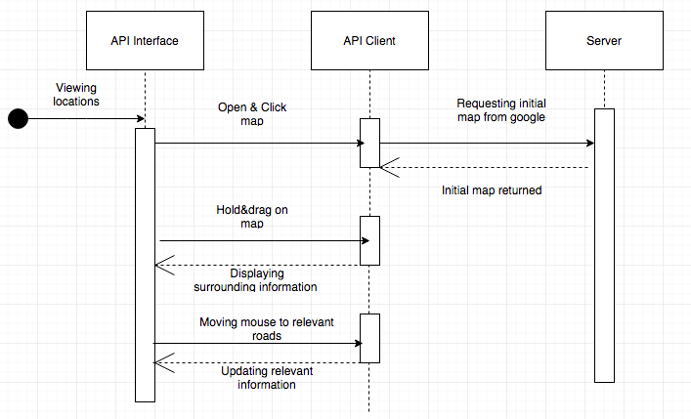
  + 2.Searching for locations by names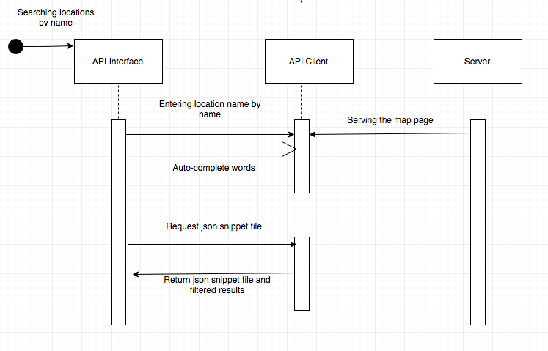
  + 3. view a list of videos, and 4.partygoers can view a list of videos discussing a selected location, in order of relevance to the location name

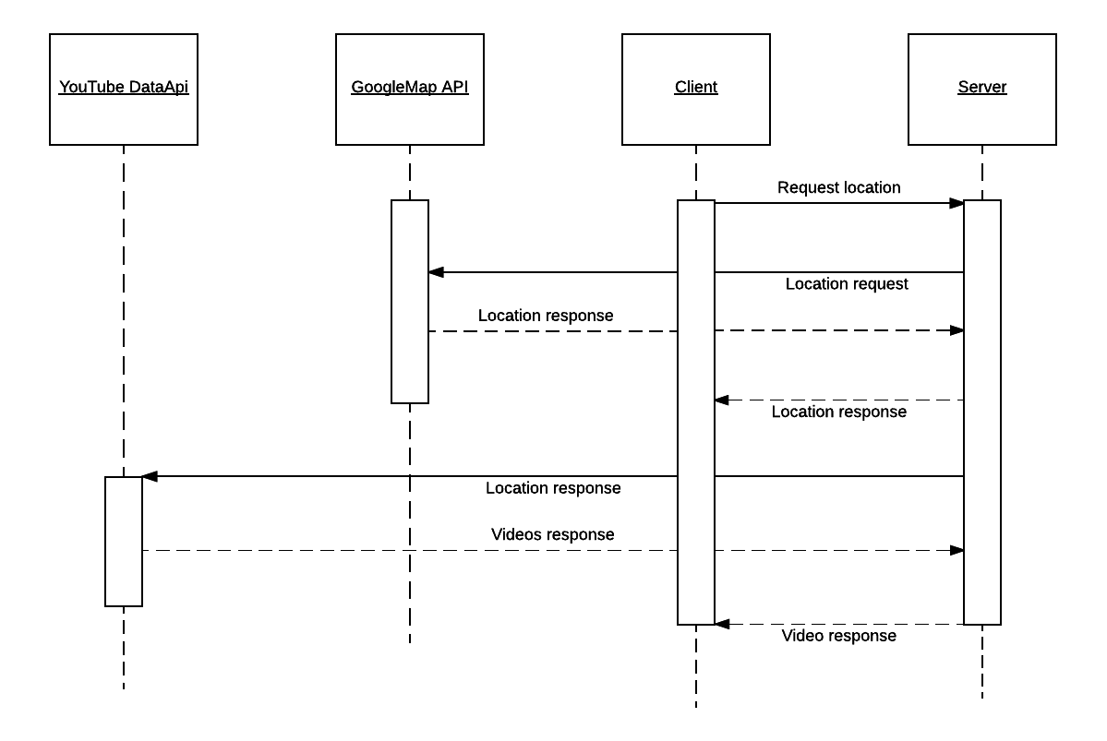

* + 5. Optimised route map
  + 6.Add location to the trip

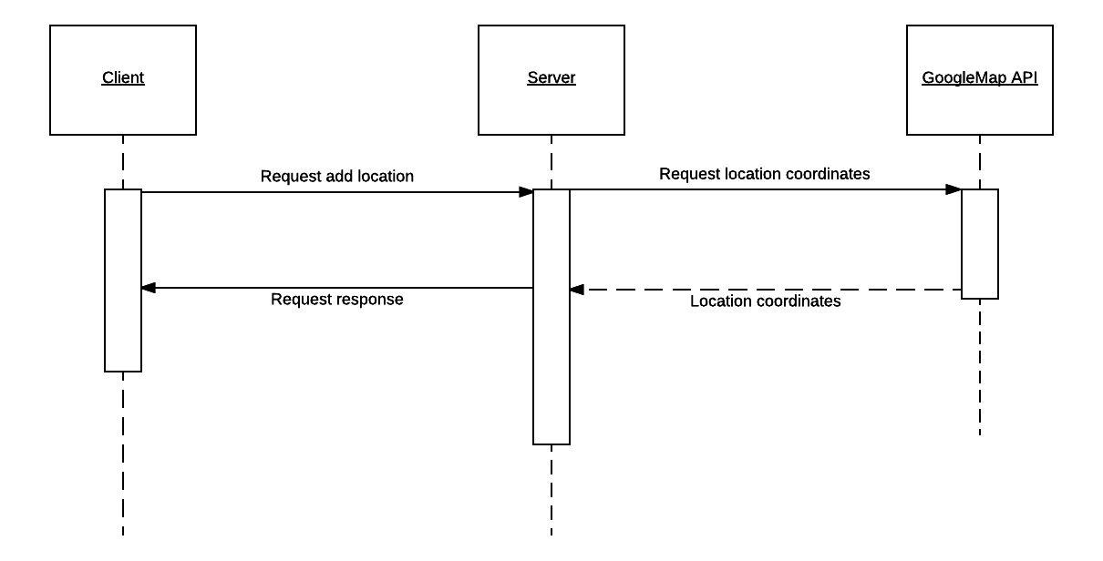

* + 7. Remove location from the trip list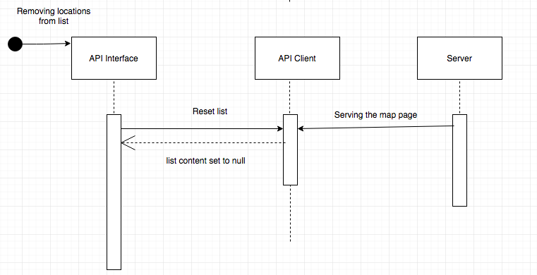
  + 8. Get recommendation for places to go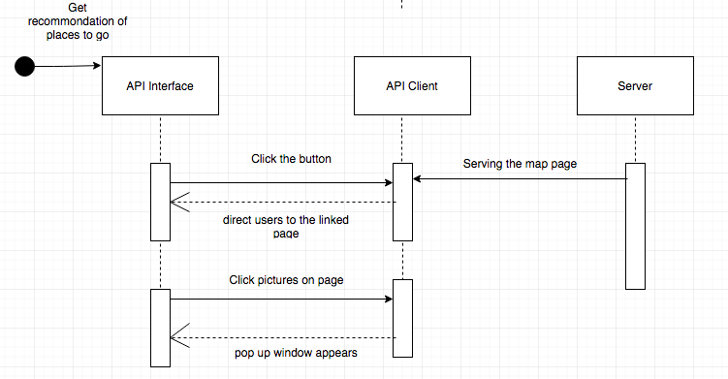

* **Add any other relevant information to your design and list key technologies used in your implementation** 
  + 1. Used bootstraps and pre-made CSS for styling and GUI improvement
  + 2. JSON was used when capturing results of searching a location by name.
  + 3. Followed most of usability heuristics when designing with the interface of our API. For example, heightened color contrast between background and materials guarantee some concern of accessibility. Moreover, intuitive icons are made for better effectiveness. Some pop up windows with kind hints are created for help documentation.
  + 4. APIs;
    - YouTube Data API for providing YouTube videos according to a search query
    - Google Directions API for obtaining directions
    - Google Maps API to display and process map
    - Wikipedia API for obtaining wikipedia information
* **Summary**

Our designs key achievement was having a strong, useful idea - being a trip planner for partygoers, which streamlines the process of discovering and researching bars, restaurants and other facilities necessary on a night out, and then allows the automated generation of a route map. This idea is useful because it streamlines the planning process for a night out, and our idea is unique in it’s composition, since our research yielded no applications which allow a user to find out about locations, have results suggested to them and then suggest an optimal route to take between all of these activities.

The key achievement of our implementation (separately from the design) was on the technological and functional side - we managed to fully implement all of the major features we set out to complete - particularly a map allowing people to view YouTube videos, a forum to give directions and a page to suggest categories. Much of the API handling was quite advanced, hence implementing this was a significant achievement.

3.Team organisation and conclusion/appraisal of your work

**Responsibilities/organisation**

The team split up responsibility for different features/components of report/research according to team agreement. Responsibilities were shared among the group and not “specialised” to a particular role. Communication was held over Facebook to discuss features of the project. Gitlab was used as the version control system for the project. Tasks were created through creating issues on Gitlab.

**How project went**

Even though our team suffered setbacks in the early reports and the initial demo, we felt that we improved significantly by the end of the course - particularly because we implemented all of the major features we had originally aimed to implement by the final demo. From discussing with other teams, we believe we have performed well in the final product, particularly on the technological side. Our demoed product was not strong in terms of UI design, however we have implemented some important UI improvements since then.

During this project, our group gained valuable experience in building a project with multiple components such as Javascript, html5 and python. One of the most significant experiences we gained was learning how to adopt a new language, since we were quite new with javascript & html. In addition, we worked with efficient and widely used methods of using combinations of languages such as html+javascript, and tools such as bootstrap for styling our elements, which broadened our knowledge in those areas.

**Issues/problems encountered**

Our biggest issue was clashes in timetables, causing some difficulty arranging times for working together as a team/have meetings. In the initial stages of the course this pushed the reports to being worked on very near the due time, however we improved on this before the final demo.

In addition, for those of us new to HTML/CSS/Javascript, writing code for the prototype presented a significant learning curve, which was a drain on productivity.

**What we would do differently now**

1. Learn Javascript/CSS/HTML before starting the course so that we can easily jump into the project
2. Have more detailed and discussed agreements on the amount of work to be completed each period (per week, or per day as assessables are nearly due) to ensure everyone knows what they should be doing, and knows when they are expected to be working on something, thus reducing the chance of the reports being done last minute
3. Have weekly meetings over Skype/in person, with minutes kept - to ensure everyone knows what is happening at a given time, and to ensure agreements can be enforced